Java Interview

# Java Core

## OOP

1. Ref

<http://javaconceptoftheday.com/access-modifiers-in-java/>

1. [Access Modifiers In Java](http://javaconceptoftheday.com/access-modifiers-in-java/)****

<http://javaconceptoftheday.com/access-modifiers-in-java/>

1. Inner class and nested Static Class in Java with Example

If a class can only be useful to one particular class, it makes sense to keep that inside the class itself; otherwise, declare it as a top level class. I actually look at JDK itself for examples and if you look at HashMap class, you will find that Map.Entry is a good example of a nested class in Java. Another popular use of nested classes are implementing [Comparator in Java](http://javarevisited.blogspot.sg/2011/06/comparator-and-comparable-in-java.html) e.g. AgeComparator for Person class.

The first and most important difference between inner class and nested static class is that inner class requires [instance](http://javarevisited.blogspot.sg/2012/02/difference-between-instance-class-and.html) of outer class for initialization and they are always associated with instance of enclosing class. On the other hand, nested static class is not associated with any instance of enclosing class.

Another difference between inner class and nested static class is that the last uses the keyword “static” in the class declaration, which means they are a static member of the class and can be accessed like any other static member of the class.

1. Static

+ Static variables:

- is a class variable and doesn’t belong to Object/instance of the class.

- static variables are shared across all the instances of Object so If one object changes the value then the change gets reflected in all the objects.

+ Static methods:

- static methods belong to class and not to class instances.

- A static method can access only static variables of class and invoke only static methods of the class.

- No need of creating an instance when using by other classes.

+ Static Class:

Static nested classes can access only static members of the outer class (Java nested classes are defined as class inside the body of another class. A nested class can be declared private, public, protected, or with default access whereas an outer class can have only public or default access.)

+ Static Block:

Java static block is the group of statements that gets executed when the class is loaded into memory by Java ClassLoader. It is used to initialize static variables of the class. Mostly it’s used to create static resources when class is loaded.

+ Static class and singleton class Difference

- Singleton class can be extended.

Static class not.

- Singleton can be passed around as an object.

Static not.

- Singleton classes can be "lazy loaded" if its an heavy object

BUT static class doesn't have such advantages and always eagerly loaded.

- Static class provides better performance than Singleton pattern

--> Because static methods are bonded on compile time.

1. Final

- Final is keyword in Java

+ Final variable

- If you make any variable as final, you cannot change the value of final variable

final int speedlimit=90;//final variable

speedLimit = 40; //Compile Error

- Blank final variable: A final variable that is not initialized at the time of declaration is known as blank final variable.

--> It can be initialized only in constructor.

final int speedlimit;//blank final variable

Bike10(){

speedlimit=70;

}

- Static blank final variable: A static final variable that is not initialized at the time of declaration is known as static blank final variable.

--> It can be initialized only in static block.

static final int data;//static blank final variable

static{ data=50;}

+ Final method:

- If you make any method as final, you cannot override it.

+ Final class:

- If you make any class as final, you cannot extend it.

- Example: String, Integer, Double and other wrapper classes are final classes.

+ Final Arraylist

- Can NOT set equal to another list

- Able to modify content of the list

+ finally & finalize

+ finally: is used in a try/catch statement. And The finally block always executes

lock.lock();

try {

//do stuff

} catch (SomeException se) {

//handle se

} finally {

lock.unlock(); //always executed, even if Exception or Error or se

}

+ finalize: finalize() is method, finalize() is called by Garbage collection just before releasing the object’s memory

public void finalize() {

//free resources (e.g. unallocate memory)

super.finalize();

}

+ Immutable class --> Use Final to create

public final class MyImmutableClass{

private final String a;

private final int b;

public MyImmutableClass(String a, int b){

}

getMethods

// NOT have setmethod

}

1. Checked vs Unchecked Exception in Java Example

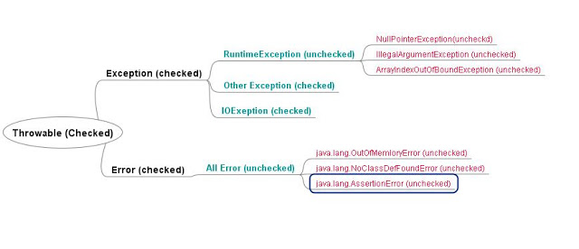

Checked Exception is required to be handled by compile time while Unchecked Exception doesn't.

Checked Exception is direct sub-Class of Exception while Unchecked Exception are of RuntimeException. CheckedException represent scenario with higher failure rate while UnCheckedException are mostly programming mistakes.

Both **java.lang.Error** and **java.lang.Exception** classes are sub classes of **java.lang.Throwable** class**,** but there exist some significant differences between them. **java.lang.Error** class represents the errors which are mainly caused by the environment in which application is running. For example, **OutOfMemoryError** occurs when JVM runs out of memory or **StackOverflowError**occurs when stack overflows.

Where as **java.lang.Exception** class represents the exceptions which are mainly caused by the application itself. For example, **NullPointerException** occurs when an application tries to access null object or **ClassCastException** occurs when an application tries to cast incompatible class types. In this article, we will discuss the differences between Error and Exception in java.

|  |  |
| --- | --- |
| **Exception** | **Error** |
| Exceptions in java are of type java.lang.Exception. | Errors in java are of type java.lang.Error. |
| Exceptions include both checked as well as unchecked type. | All errors in java are unchecked type. |
| Checked exceptions are known to compiler where as unchecked exceptions are not known to compiler because they occur at run time. | Errors happen at run time. They will not be known to compiler. |
| You can recover from exceptions by handling them through try-catch blocks. | It is impossible to recover from errors. |
| Exceptions are mainly caused by the application itself. | Errors are mostly caused by the environment in which application is running. |
| Examples : Checked Exceptions : SQLException, IOException Unchecked Exceptions : ArrayIndexOutOfBoundException, ClassCastException, NullPointerException | Examples : java.lang.StackOverflowError, java.lang.OutOfMemoryError |

1. How to create thread safe Singleton in Java - Java Singleton Example?

Singleton using Enum in Java

By default creation of Enum instance is thread safe but any other method on Enum is programmers responsibility.

**public** **enum** EasySingleton{  
    INSTANCE;  
}

Singleton example with double checked locking

***/\*\*  
\* Singleton pattern example with Double checked Locking  
\*/***

**public** **class** DoubleCheckedLockingSingleton{  
     **private** **volatile** DoubleCheckedLockingSingleton INSTANCE;  
    
     **private** DoubleCheckedLockingSingleton(){}  
    
     **public** DoubleCheckedLockingSingleton getInstance(){  
         **if**(INSTANCE == **null**){  
            **synchronized**(DoubleCheckedLockingSingleton.**class**){  
                *//double checking Singleton instance*  
                **if**(INSTANCE == **null**){  
                    INSTANCE = **new** DoubleCheckedLockingSingleton();  
                }  
            }  
         }  
         **return** INSTANCE;  
     }  
}

Singleton pattern with static factory method

This is one of my favorite method to impelemnt Singleton pattern in Java, Since Singleton instance is [static](http://javarevisited.blogspot.sg/2011/11/static-keyword-method-variable-java.html) and [final variable](http://javarevisited.blogspot.sg/2011/12/final-variable-method-class-java.html) it initialized when class is first loaded into memeory so creation of instance is inherently thread-safe.

***/\*\*  
\* Singleton pattern example with static factory method  
\*/***  
  
**public** **class** Singleton{  
    *//initailzed during class loading*  
    **private** **static** **final** Singleton INSTANCE = **new** Singleton();  
    
    *//to prevent creating another instance of Singleton*  
    **private** Singleton(){}  
  
    **public** **static** Singleton getSingleton(){  
        **return** INSTANCE;  
    }  
}

Enum Singletons handled Serialization by themselves

Another problem with conventional Singletons are that once you implement [serializable interface](http://javarevisited.blogspot.sg/2011/04/top-10-java-serialization-interview.html) they are no longer remain Singleton because readObject() method always return a new instance just like constructor in Java. you can avoid that by using readResolve() method and discarding newly created instance by replacing with Singeton as shwon in below example :

*//readResolve to prevent another instance of Singleton*  
    **private** Object readResolve(){  
        **return** INSTANCE;  
    }

1. How HashMap works?

HashMap maintains an array of buckets.

When hashcode is same, bucket location would be same and collision will occur in HashMap Since HashMap uses LinkedList to store object, this entry (object of Map.Entry comprise key and value )  will be stored in [LinkedList](http://javarevisited.blogspot.sg/2012/02/difference-between-linkedlist-vs.html).

HashMap  stores both Key and Value in LinkedList

After finding bucket location, we will call keys.equals() method to identify a correct node in LinkedList and return associated value object for that key in Java HashMap.   
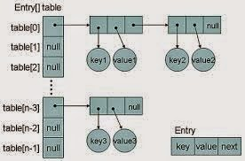

Read more: <https://javarevisited.blogspot.com/2011/02/how-hashmap-works-in-java.html#ixzz5JAo36huY>

1. Can we use any custom object as a key in HashMap?

Need to override both equal() and hashcode() method.

The custom object must be immutable because you cannot change once it created.

1. What is the difference between creating String as new() and literal?

When we create the string with new() Operator, it’s created in heap and not added into string pool while String created using literal are created in String pool itself which exists in PermGen area of heap

**String** str **=** **new** **String**("Test")

does not put the object str in String pool, we need to call String.intern() method which is used to put them into String pool explicitly. It's only when you create String object as String literal e.g. String s = "Test" Java automatically put that into String pool.

1. How clone method works in Java?

The clone() method is used to create a copy of an Object in Java.

Since Object class' clone() method creates copy by creating new instance, and then copying field-by-field, similar to assignment operator, it's fine for primitives and Immutable object, but not suited if your class contains some mutable data structure e.g. Collection classes likeArrayList or [arrays](http://javarevisited.blogspot.sg/2011/06/converting-array-to-arraylist-in-java.html). In that case, both original object and copy of the object will point to the same object in the heap. You can prevent this by using the technique known as deep cloning, on which each mutable field is cloned separately.

* Let the class, which supports cloning implements Cloneable interface. (failure to do this will result in CloneNotSupportedException).
* Override protected clone() method from java.lang.Object class.
* In overridden clone(), first call super.clone() to get the shallow copy of object.
* If your class contains any Collection or Mutable object, than [deep copy](http://java67.blogspot.sg/2013/05/difference-between-deep-copy-vs-shallow-cloning-java.html) of those field. Like in our example, Programmer class contains List in it's certification field, when super.clone() will return, both original and cloned object will point to same object. To fix this, we reassign certification fields of clone object by explicitly copying data, as shown in following line :

clone.certifications = new ArrayList(certifications); //deep copying

Read more: <https://javarevisited.blogspot.com/2015/01/java-clone-tutorial-part-2-overriding-with-mutable-field-example.html#ixzz5JD8qpVhs>

1. What is Autoboxing and Unboxing in Java?

When Java automatically converts a primitive type like int into corresponding wrapper class object e.g. [Integer](http://javarevisited.blogspot.sg/2011/08/convert-string-to-integer-to-string.html) than its called autoboxing  because primitive is boxed into wrapper class while in opposite case is called unboxing, where an Integer object is converted into primitive int.

Unnecessary Object creation due to Autoboxing in Java  
One of the dangers of autoboxing is throw away object which gets created if autoboxing occurs in a loop. Here is an example of how unnecessary object can slow down your application :

**Integer** sum = 0;  
 **for**(**int** i=1000; i<5000; i++){  
   sum+=i;  
 }

In this code sum+=i will expand as sum = sum + i and since + operator is not applicable to Integer object it will trigger unboxing of sum Integer object and then autoboxing of result which will be stored in sum which is Integer as shown below :

**sum = sum.intValue() + i;  
Integer sum = new Integer(result);**

here since the sum is Integer, it will create around 4000 unnecessary Integer object which are just throw away and if this happens on a large scale has It potential to slow down system with [frequent GC](http://javarevisited.blogspot.sg/2011/04/garbage-collection-in-java.html) for arithmetic calculation always prefer primitive over boxed primitive and look for unintentional autoboxing in Java.

Read more: <https://javarevisited.blogspot.com/2012/07/auto-boxing-and-unboxing-in-java-be.html#ixzz5HNKLWLWv>

1. Serialization

Object **Serialization** is a process used to convert Object into a binary format which can be persisted in disk or sent over network.

The serialVersionUID represents your class version, and you should increment it if the current version of your class is modified such that it is no longer backwards compatible with its previous version.

Serializable vs Externalizable

* Serializable: JVM has full of control for serializing object.
* Externalizable: App needs control for serializing and de-serializing object.
  + writeExternal() and readExternal()

<https://howtodoinjava.com/core-java/serialization/serialversionuid-in-java-and-related-fast-facts/>

## Multithreading, concurrency and thread basics

1. What is Thread in Java?

* Threads consumes CPU in best possible manner, hence enables multi processing. Multi threading reduces idle time of CPU which improves performance of application.
* Thread are light weight process.
* A thread class belongs to java.lang package.
* We can create multiple threads in java, even if we don’t create any Thread, one Thread at least do exist i.e. main thread.
* Multiple threads run parallelly in java.
* Threads have their own stack.
* Advantage of Thread : Suppose one thread needs 10 minutes to get certain task, 10 threads used at a time could complete that task in 1 minute, because threads can run parallely.

1. Does Thread implements their own Stack, if yes how? (Important)

Yes, [Threads have their own stack](http://www.javamadesoeasy.com/2015/03/threads-implement-their-own-stack.html). This is very interesting question, where interviewer tends to check your basic knowledge about how [threads internally maintains their own stacks](http://www.javamadesoeasy.com/2015/03/threads-implement-their-own-stack.html). I’ll be explaining you the concept by diagram.

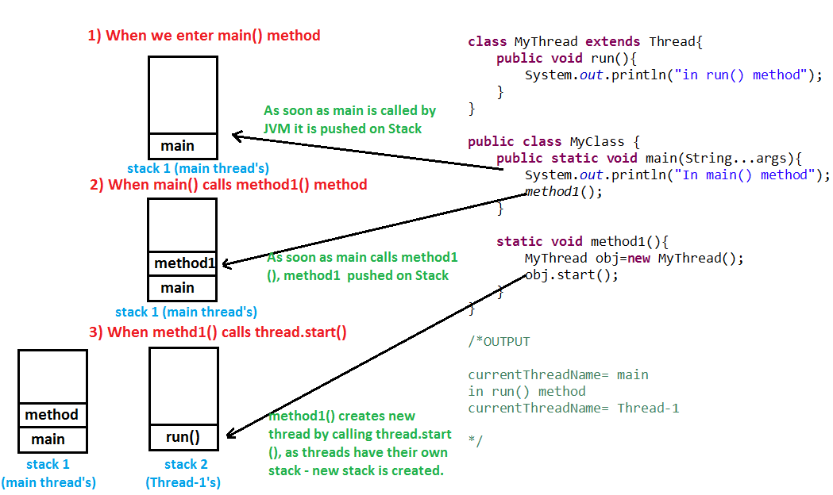

1. What is the difference between a Thread and an Executor?

Creating a running thread in Java is an expensive operation, and an operating system may limit the number of threads provided to a running application at any one time. By using a thread pool, you can create threads when needed, and, rather than creating new threads, you can reuse a thread after it has completed running previous code.

1. How can you ensure all threads that started from main must end in order in which they started and also main should end in last? (Important)

We can use [join() method](http://www.javamadesoeasy.com/2015/03/join-method-ensure-all-threads-that.html) to ensure all threads that started from main must end in order in which they started and also main should end in last.In other words waits for this thread to die. Calling join() method internally calls join(0);

<https://www.journaldev.com/1024/java-thread-join-example>

1. What is significance of using [Volatile](http://www.javamadesoeasy.com/2015/03/volatile-keyword-in-java-difference.html) keyword? (Important)

If a field is declared [volatile](http://www.javamadesoeasy.com/2015/03/volatile-keyword-in-java-difference.html), in that case the Java memory model ensures that all threads see a consistent value for the variable.

<http://www.javamadesoeasy.com/2015/03/volatile-keyword-in-java-difference.html>

1. Why wait(), notify()  and notifyAll() are in Object class and not in Thread class? (Important)

Every Object has a monitor, acquiring that monitors allow thread to hold lock on object.

wait(), notify() and notifyAll() are called on objects only > When wait() method is called on object by thread it waits for another thread on that object to release object monitor by calling [notify() or notifyAll()](http://www.javamadesoeasy.com/2015/03/difference-between-notify-and-notifyall.html) method on that object.

1. What is ThreadLocal?

Java ThreadLocal is used to create thread-local variables. We know that all threads of an Object share it’s variables, so if the variable is not thread safe, we can use synchronization but if we want to avoid synchronization, we can use ThreadLocal variables.  
Every thread has it’s own ThreadLocal variable and they can use it’s get() and set() methods to get the default value or change it’s value local to Thread. ThreadLocal instances are typically private static fields in classes that wish to associate state with a thread. Check this post for small example program showing [ThreadLocal Example](https://www.journaldev.com/1076/java-threadlocal-example).

<https://www.journaldev.com/1076/java-threadlocal-example>

1. What is [deadlock](http://www.javamadesoeasy.com/2015/03/deadlock-in-multithreading-program-to.html) in multithreading? Write a program to form [DeadLock](http://www.javamadesoeasy.com/2015/03/deadlock-in-multithreading-program-to.html)in multi threading and also how to solve DeadLock situation. What measures you should take to avoid deadlock? (Important)

<https://javarevisited.blogspot.com/2010/10/what-is-deadlock-in-java-how-to-fix-it.html>

Two or more threads are waiting for each other to release lock and get stuck for infinite time, situation is called deadlock.



if you provide an ordered access then problem will be resolved , here is my fixed version, which avoids deadlock by avoiding circular wait with no preemption.



1. What are differences between wait and sleep method in Java?

The only major difference is to wait for release the lock or monitor while sleep doesn't release any lock or monitor while waiting. The wait is used for inter-thread communication while sleep is used to introduce pause on execution.

<http://javarevisited.blogspot.sg/2011/12/difference-between-wait-sleep-yield.html>

1. Difference between ExecutorService.submit() and Executor.execute() methods in Java?

<https://javarevisited.blogspot.it/2016/04/difference-between-ExecutorServie-submit-vs-Executor-execute-method-in-Java.html>

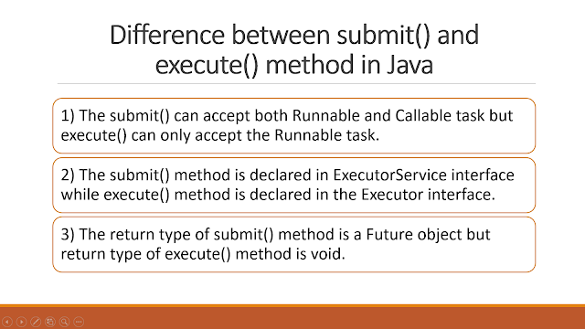

1. The real difference between Process and Thread.

The main difference between them  is that a Process is a program which is executing some code and a thread is an [independent path of execution](http://javarevisited.blogspot.com/2014/07/top-50-java-multithreading-interview-questions-answers.html) in the process. A process can have more than one thread for doing independent task e.g. a thread for reading data from disk, a thread for processing that data and another thread for sending that data over the network.

Technically, most significant difference between thread is address space and context switching. All thread from a process share same address space but a process has their own address space. Similarly, context switching between process is more expensive than context switching between threads.

1. Why wait notify and notifyAll called from synchronized block or method in Java

IllegalMonitorStateException in Java which will occur if we don't call wait (), notify () or notifyAll () method from synchronized context.

In order to call the wait (), notify () or notifyAll () methods in Java, we must have obtained the lock for the object on which we're calling the method.

1. How to Stop Thread in Java Code Example

By default, a Thread stops when execution of run() method finish either normally or due to any Exception. In this article, we will How to Stop Thread in Java by using a boolean State variable or flag. Using a flag to stop Thread is a very popular way  of stopping the thread and it's also safe because it doesn't do anything special rather than helping run() method to finish itself.



*Should we make bExit Volatile*

How to Stop Thread in Java Tutorial ExampleSince every Thread has its own local memory in Java

its good practice to make bExit volatile because we may alter the value of bExit

from any thread and make it volatile guarantees that Runner will also see any update done before making bExit.

1. What is the difference between synchronized and concurrent collection in Java?

In Summary concurrent collections use advanced technique to achieve thread-safety without compromising Scalability. For example, [ConcurrentHashMap](http://javarevisited.blogspot.com/2013/02/concurrenthashmap-in-java-example-tutorial-working.html" \t "_blank)only locks certain portion of Map while Hashtable locks full map while doing iteration or performing any write operation.

1. What is the difference between Stack and Heap in Java

Why does someone this question as part of multi-threading and concurrency? because Stack is a memory area which is closely associated with threads. To answer this question, both stack and heap are specific memories in Java application. Each thread has their own stack, which is used to store local variables, method parameters and call stack. Variable stored in one Thread's stack is not visible to other. On another hand, the heap is a common memory area which is shared by all threads. Objects whether local or at any level is created inside heap. To improve performance thread tends to cache values from heap into their stack, which can create problems if that variable is modified by more than one thread, this is where volatile variables come into the picture. volatile suggest threads read the value of variable always from main memory. See this [article](http://javarevisited.blogspot.com/2013/01/difference-between-stack-and-heap-java.html) for learning more about stack and heap in Java to answer this question in greater detai

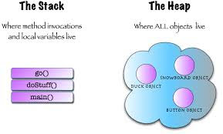

1. How to check if a thread holds lock on a particular object in Java

* I thought about **IllegalMonitorStateException**which [wait() and notify() methods](http://javarevisited.blogspot.com/2011/05/wait-notify-and-notifyall-in-java.html)throw when they get called from non-synchronized context so I said I would call newspaper.wait() and if this call [throws an exception](http://javarevisited.blogspot.com/2012/02/difference-between-throw-and-throws-in.html) it means thread in Java is not holding the lock, otherwise thread holds the lock.
* Later I discovered that thread is a static method called holdsLock(Object obj) which returns true or false based on whether threads holds a lock on the object passed (The java.lang.Thread.holdsLock() method returns true if and only if the current thread holds the monitor lock on the specified object.).

1. JavaRef:

<https://javarevisited.blogspot.it/2011/07/java-multi-threading-interview.html>

<https://javarevisited.blogspot.com/2014/07/top-50-java-multithreading-interview-questions-answers.html>

## Java collections framework

1. Difference between fail-fast Iterator vs fail-safe Iterator in Java

|  |  |
| --- | --- |
| **Fail-fast iterator** | **fail-safe iterator** |
| Structural changes means adding, removing or updating any element from collection while one thread is Iterating over that collection. fail-fast behavior is implemented by keeping a modification count and if iteration thread realizes the change in modification count it throws ConcurrentModificationException. | Contrary to fail-fast Iterator, fail-safe iterator doesn't throw any Exception if Collection is modified structurally  while one thread is Iterating over it because they work on clone of Collection instead of original collection and that’s why they are called as fail-safe iterator. Iterator of CopyOnWriteArrayList is an example of fail-safe Iterator also iterator written by ConcurrentHashMap keySet is also fail-safe iterator and never throw ConcurrentModificationException in Java. |

1. Difference between HashMap and HashSet in Java

|  |  |
| --- | --- |
| **HashMap** | **Hash Set** |
| HashMap  is an implementation of Map interface | HashSet is an implementation of Set Interface |
| HashMap Stores data in form of  key-value pair | HashSet Store only objects |
| Put method is used to add element in map | Add method is used to add element is Set |
| In hash map hashcode value is calculated using key object | Here member object is used for calculating hashcode value which can be same for two objects so equal () method is used to check for equality if it returns false that means two objects are different. |
| HashMap is faster than HashSet because unique key is used to access object | HashSet is slower than Hashmap |

1. Difference between HashMap, LinkedHashMap and TreeMap in Java

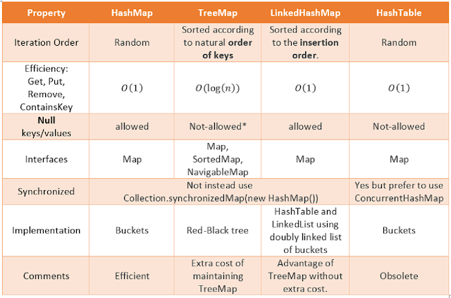

1. What is difference between Enumeration and Iterator in Java?

|  |  |
| --- | --- |
| **Enumeration** | **Iterator** |
| hasMoreElement() | hasNext() |
| nextElement() | next() |
| NA | remove() |

1. ConcurrentHashMap

<https://javarevisited.blogspot.com/2017/08/top-10-java-concurrenthashmap-interview.html>

1. How HashMap works in Java?

<https://javarevisited.blogspot.com/2011/02/how-hashmap-works-in-java.html>

1. What is difference between Synchronized and Concurrent Collections in Java?

<https://javarevisited.blogspot.com/2016/05/what-is-difference-between-synchronized.html>

1. When do you use ConcurrentHashMap in Java?

This is another advanced level collection interview questions in Java which normally asked to check whether the interviewer is familiar with optimization done on ConcurrentHashMap or not. ConcurrentHashMap is better suited for situation where you have multiple readers and one

Writer or fewer writers since Map gets locked only during the write operation. If you have an equal number of reader and writer than [ConcurrentHashMap](http://javarevisited.blogspot.com/2011/04/difference-between-concurrenthashmap.html) will perform in the line of Hashtable or synchronized HashMap.

## Hibernate

1. What is JPA? How is Hibernate related to JPA?

JPA (Java Persistence API) is a specification of how the object relational mapping should be done. Java is an object oriented programming language. Data from java objects need to be stored in relational (sql based) tables. JPA defines the specification (interface) of how the mapping should be done. JPA is just a specification with no implementation. Hibernate is an implementation of the JPA specification. All annotations specified by JPA are implemented by Hibernate. The main benefit of using JPA is that at a later point in time, you can easily switch to another implementation of JPA (different from Hibernate). If I directly use Hibernate annotations, I'm locked in to Hibernate. I cannot easily switch to another ORM framework.

1. Entity object life cycle

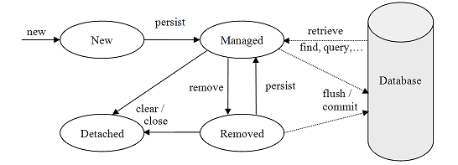

When an entity object is initially created its state is **New**.  In this state the object is not yet associated with an [EntityManager](https://www.objectdb.com/api/java/jpa/EntityManager) and has no representation in the database.

An entity object becomes Managed when it is persisted to the database via an EntityManager’s [persist](https://www.objectdb.com/api/java/jpa/EntityManager/persist_Object)method, which must be invoked within an active transaction. On transaction commit, the owning EntityManager stores the new entity object to the database. Entity objects retrieved from the database by an EntityManager are also in the Managed state.

A managed entity object can also be retrieved from the database and marked for deletion, by using the EntityManager’s [remove](https://www.objectdb.com/api/java/jpa/EntityManager/remove_Object)method within an active transaction. The entity object changes its state from Managed to Removed, and is physically deleted from the database during commit.

The last state, Detached, represents entity objects that have been disconnected from the EntityManager. For instance, all the managed objects of an EntityManager become detached when the EntityManager is closed. Working with detached objects, including merging them back to an EntityManager.

The persistence context is the collection of all the managed objects of an EntityManager. If an entity object that has to be retrieved already exists in the persistence context, the existing managed entity object is returned without actually accessing the database (except retrieval by [refresh](https://www.objectdb.com/api/java/jpa/EntityManager/refresh_Object_LockModeType), which always requires accessing the database).

The main role of the persistence context is to make sure that a database entity object is represented by no more than one in-memory entity object within the same EntityManager. Every EntityManager manages its own persistence context.

1. Difference between get and load in Hibernate

* Get method of Hibernate Session class returns null if object is not found in cache as well as on database while load() method [throws](http://javarevisited.blogspot.sg/2012/02/difference-between-throw-and-throws-in.html) ObjectNotFoundException if object is not found on cache as well as on database but never return null.
* Get method never returns a proxy, it either returns null or fully initialized Object, while load()method may return proxy, which is the object with ID but without initializing other properties, which is lazily initialized. If you are just using returned object for creating relationship and only need Id then load() is the way to go.

|  |
| --- |
| *//Example of calling get method of Hiberante Session class* **Session** session = SessionFactory.getCurrentSession(); **Employee** Employee = (Employee) session.get(Employee.**class**, EmployeeID);  *//Example of calling load method of Hiberante Session* **Session** session = SessionFactory.getCurrentSession(); **Employee** Employee = (Employee) session.load(Employee.**class**, EmployeeID); |

1. Difference between save vs persist and saveOrUpdate in Hibernate

Hibernate **Session** class provides couple of ways to save object into database by methods like **save**, **saveOrUpdate** and **persist**.

Main difference between save and saveOrUpdate method is that save() generates a new identifier and INSERT record into [database](http://javarevisited.blogspot.sg/2011/10/selct-command-sql-query-example.html) while saveOrUpdatecan either INSERT or UPDATE based upon existence of record. Clearly saveOrUpdate is more flexible in terms of use but it involves an extra processing to find out whether record already exists in table or not.

Hibernate persist is similar to save (with transaction) and it adds the entity object to the persistent context, so any further changes are tracked. If the object properties are changed before the transaction is committed or session is flushed, it will also be saved into database.

Second difference is that we can use persist() method only within the boundary of a transaction, so it’s safe and takes care of any cascaded objects.

Finally, persist doesn’t return anything so we need to use the persisted object to get the generated identifier value. Let’s look at hibernate persist with a simple program.

1. What is SessionFactory in Hibernate? is SessionFactory thread-safe?

SessionFactory, as the name suggest, is a factory to hibernate Session objects. SessionFactory is often built during start-up and used by application code to get session object. It acts as a single data store and it's also [thread-safe](http://javarevisited.blogspot.com/2012/12/how-to-create-thread-safe-singleton-in-java-example.html) so that multiple threads can use the same SessionFactory. Usually, a Java JEE application has just one SessionFactory, and individual threads, which are servicing client’s request obtain hibernate Session instances from this factory, that’s why any implementation of SessionFactory interface must be thread-safe.

1. What is Session in Hibernate? Can we share single Session among multiple threads in Hibernate?

Session represent a small unit of work in Hibernate, they maintain a connection with the database and they are not thread-safe, it means you can not share Hibernate Session between multiple threads. Though Session obtains database connection lazily it's good to close session as soon as you are done with it.

1. Why it's important to provide no argument constructor in Hibernate Entities?

Every Hibernate Entity class must contain a [no argument constructor](http://javarevisited.blogspot.com/2012/12/what-is-constructor-in-java-example-chainning-overloading.html), because Hibernate framework creates an instance of them using Reflection API, by calling Class.newInstance() method. This method will throw InstantiationException if it doesn't found any argument constructor inside Entity class.

1. Can we make a Hibernate Entity Class final?

Yes, you can make a Hibernate Entity class final, but that's not a good practice. Since Hibernate uses a proxy pattern for performance improvement in the case of the lazy association, by making an entity final, Hibernate will no longer be able to use a proxy, because [Java doesn't allow extension of the final class](http://javarevisited.blogspot.com/2011/12/final-variable-method-class-java.html), thus limiting your performance improvement options.

1. Difference between First and Second Level Cache in Hibernate

**Scope:**

The first difference is that first level cache is maintained at Session level while the second level cache is maintained at SessionFactory level (the application level).  
The data stored in the first level cache is accessible to the only Session who maintains it, while the Second level cache is accessible to all.  
First level cache is by default enabled while the second level cache is by default disabled. and you need to configure the second level cache in Hibernate configuration file to enable it. The second level cache is provided with the help of caching providers e.g. EhCache and OSCache.  
  
A couple of things to know about hibernate first level cache:  
  
1) You can use Session.evict() to remove the loaded entity from the first level cache, can use refresh() method to refresh the cache and can use clear() method to remove all entities in cache.  
  
2) You cannot disable the first level cache, it always enabled.  
  
3) Hibernate entities or database rows remain in cache only until Session is open, once Session is closed, all associated cached data is lost.  
  
Read more: <http://www.java67.com/2017/10/difference-between-first-level-and-second-level-cache-in-Hibernate.html#ixzz5JDNKTjFH>

**Configuration:**

First level cache is by default enabled in Hibernate, while the second level cache is optional. If you need it then you need to explicitly enable the second level cache on Hibernate configuration file i.e. the hibernate.cfg.xml file

You can use the hibernate.cache.provider\_class and hibernate.cache.use\_second\_level\_cache properties to enable the second level cache in Hibernate. The first one is the name of the class which implements Second level cache and could be different, depending upon which cache you use e.g. EhCache or OSCache.

<https://javarevisited.blogspot.com/2017/03/difference-between-first-and-second-level-cache-in-Hibernate.html>

1. Hibernate "Cascade"

When we have relationship between entities --> then we need to define how the different operations will affect the other entity. This is done by cascading (and there are different types of it.)

None: No Cascading, it’s not a type but when we don’t define any cascading then no operations in parent affects the child.

ALL: Cascades save, delete, update, evict, lock, replicate, merge, persist. Basically everything

SAVE\_UPDATE: Cascades save and update, available only in hibernate.

DELETE: Corresponds to the Hibernate native DELETE action, only in hibernate.

DETATCH, MERGE, PERSIST, REFRESH and REMOVE – for similar operations

LOCK: Corresponds to the Hibernate native LOCK action.

REPLICATE: Corresponds to the Hibernate native REPLICATE action.

1. Cascade vs Inverse

+ Inverse:

- This is used to decide which side is the relationship owner to manage the relationship (insert or update of the foreign key column).

- Default inverse = false

+ Cascade:

In cascade, after one operation (save, update and delete) is done, it decides whether it need to call other operations (save, update and delete) on another entities which has relationship with each other.

1. Producer Consumer Design Pattern with Blocking Queue Example in Java

<https://javarevisited.blogspot.com/2012/02/producer-consumer-design-pattern-with.html>

## Spring framework

1. How Spring MVC Framework works? How HTTP Request is processed?

<https://javarevisited.blogspot.com/2017/06/how-spring-mvc-framework-works-web-flow.html>

* Client sends an HTTP request to a specific URL
* DispatcherServlet of Spring MVC receives the request
* It passes the request to a specific controller depending on the URL requested using @Controller and @RequestMapping annotations.
* Spring MVC Controller then returns a logical view name and model to DispatcherServlet.
* DispatcherServlet consults view resolvers until actual View is determined to render the output
* DispatcherServlet contacts the chosen view (e.g. Thymeleaf, Freemarker, JSP) with model data and it renders the output depending on the model data
* The rendered output is returned to the client as response  
  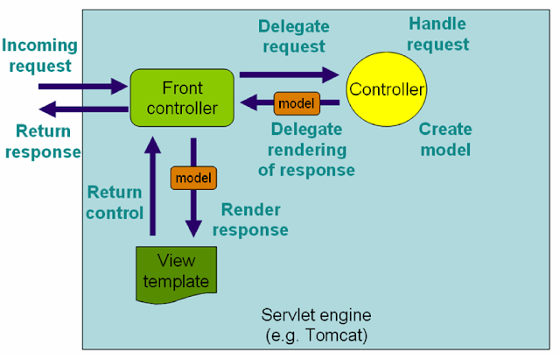

1. IOC( Inversion of Control) and DI (Dependency Injection)

IoC Containers control and manage the life cycle of some objects: creation, destruction and callback invocations. That means instead of you are creating an object using the new operator, let the container do that for you.

In Spring frameowork, Dependency Injection (DI) design pattern is used to define the object dependencies between each other. Spring only supports 2 the injection types :

* Setter Injection
* Constructor Injection

1. What is Bean scope in Spring MVC framework with Example

* Singleton (default scope)

Singleton bean scope is like [Singleton pattern in Java](http://javarevisited.blogspot.com/2011/03/10-interview-questions-on-singleton.html) where only one instance of bean is created per Spring container.

* Prototype
* Request
* Session
* Global-session

Read more: <https://javarevisited.blogspot.com/2012/05/what-is-bean-scope-in-spring-mvc.html#ixzz5Ha2vIN6Q>

1. Difference between @Autowired and @Inject annotation in Spring?

@Inject is a standard annotation defined by JSR-330 and @Autowired is spring specific. In theory, if you move to another DI framework like Google Guice, @Inject will work there. Since Spring is most popular DI and IOC container for Java application, @Autowired is more common and @Inject is lesser known, but from portability point of view, its better to use @Inject. Spring 3.0 supports JSR-330 annotation, so if you are using Spring 3.0 or higher release, prefer @Inject over @Autowired.  
  
Read more: <https://javarevisited.blogspot.com/2017/04/difference-between-autowired-and-inject-annotation-in-spring-framework.html#ixzz5HxgWkcup>

1. DispatcherServlet

<https://javarevisited.blogspot.com/2017/09/dispatcherservlet-of-spring-mvc-10-points-to-remember.html>

* The DispatcherServlet is the main controller of Spring MVC Application. All incoming web request passes through DispatcherServlet before processed by individual Spring controllers i.e classes annotated using @Controller annotation.
* The DispatcherServlet of Spring MVC is an Implementation of Front Controller Pattern (see [Introduction to Spring MVC 4](https://pluralsight.pxf.io/c/1193463/424552/7490?u=https%3A%2F%2Fwww.pluralsight.com%2Fcourses%2Fspring-mvc4-introduction)). A Front Controller is nothing but a controller that handles all requests for a website. They are often used in Web applications to implement workflows.
* The DispatcherServlet is an actual Servlet, it inherits from the HttpServlet base class. Servlet engine like Tomcat create an instance of this class and calls it various life-cycle methods e.g. init(), service() and destroy().  
  The dispatcher servlet is configured as load-on-startup = 1 which means this Servlet should be created by Servlet container when you deploy the application rather than creating when a request arrived for this request. This is done to reduce the response time of the first request because DispatcherServlet does a lot of job at the startup to scan and find all controllers and request mappings.
* During initialization of DispatcherServlet, the Spring MVC framework will look for a file named [servlet-name]-servlet.xml in the WEB-INF directory of your web application and create the beans defined there e.g. if servlet name is "SpringMVC" as shown in the above web.xml configuration then it will look for a file named SpringMVC-Servlet.xml. It also overrides the definitions of any beans defined with the same name in the global scope. You can change the exact location of this configuration file by using contextConfigLocation servlet initialization parameter.  
    
  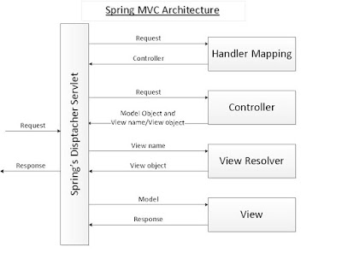

The DispatcherServlet is the backbone of Spring MVC and serves as the main controller which routes different HTTP request to corresponding Spring Controllers. It is an implementation of Front Controller design pattern and provides a single entry point to your Spring web application. You configure DispatcherServlet in the web.xml but gives it load-on-startup value 1 to suggest container to load this Servlet during startup and not when a request comes up. This reduces response time for the first request.  
  
Read more: <https://javarevisited.blogspot.com/2017/09/dispatcherservlet-of-spring-mvc-10-points-to-remember.html#ixzz5I2ONaogY>

1. InternalResourceViewResolver

The **InternalResourceViewResolver**is an implementation of ViewResolver in Spring MVC framework which resolves logical view name e.g. "hello" to internal physical resources e.g. Servlet and JSP files e.g. jsp files placed under WEB-INF folder. It is a subclass of UrlBasedViewResolver, which uses "prefix" and "suffix" to convert a logical view name returned from Spring controller to map to actual, physical views. For example, if a user tries to access /home URL and HomeController returns "home" then [DispatcherServlet](http://javarevisited.blogspot.sg/2015/09/eclipse-javalangclassnotfoundexception.html" \t "_blank) will consult InternalResourceViewResolver and it will use prefix and suffix to find the actual physical view which is integral to a web application. For example, if prefix is "/WEB-INF/views/" and suffix is ".jsp"then "home" will be resolved to "/WEB-INF/home.jsp" by InternalResourceViewResolver.

**Configuring ViewResolver using XML in Spring**  
Here is some XML snippet to configure a view resolve in Spring, you can use this if you are working on a Spring project which is using XML based confirmation:

<bean id="viewResolver"

class="org.springframework.web.servlet.view.InternalResourceViewResolver" prefix="/WEB-INF/" suffix=".jsp" />

**Configuring ViewResolver using Java Configuration**  
From Spring 3.0 you can also configure view resolver using Java i.e. without XML. You can use following code to configure internal resource view resolver in your spring project:

@Bean

public ViewResolver viewResolver() {

InternalResourceViewResolver irv = new InternalResourceViewResolver();

irv.setPrefix("/WEB-INF/");

irv.setSuffix(".jsp");

return irv;

}

Read more: <https://javarevisited.blogspot.com/2017/08/what-does-internalresourceviewresolver-do-in-spring-mvc.html#ixzz5I2TSloPE>

1. REST INTERVIEW

<https://javarevisited.blogspot.com/2018/02/top-20-spring-rest-interview-questions-answers-java.html#axzz5HZt43YAW>

1. What is the difference between @Controller and @RestController?  
   The key difference between a traditional Spring MVC @Controller and the RESTful web service @RestController is the way the HTTP response body is created. While the traditional MVC controller relies on the View technology, the RESTful web service controller simply returns the object and the object data is written directly to the HTTP response as JSON/XML by registered HttpMessageConverters.

The @ResponseBody annotation can be put on a method to indicates that the return type should be written directly to the HTTP response body (and not placed in a Model, or interpreted as a view name).  
  
Read more: <https://javarevisited.blogspot.com/2018/02/top-20-spring-rest-interview-questions-answers-java.html#ixzz5I3fJRfIO>

1. What is the HTTP status return code for a successful DELETE statement?  
   Either we can return HTTP status 204 (NO CONTENT) with no response body or return HTTP status 200 (OK) along with a response body with representation of the deleted item.
2. Name some common http response codes. When do you need @ResponseStatus?

**2xx Success**

200 OK

201 Created

204 No Content

**3xx Redirection**

304 Not Modified

**4xx Client Error**

400 Bad Request

401 Unauthorized

403 Forbidden

404 Not Found

409 Conflict

**5xx Server Error**

500 Internal Server Error

503 Service Unavailable

1. Explain the term ‘Statelessness’ with respect to RESTful WEB service.

The state of the client’s application is never stored on the server and is passed on. In this process, the clients send all the information that is required for the server to fulfill the HTTP request that has been sent. Thus every client request and the response is independent of the other with complete assurance of providing required information.

1. Global Exception Handling With @ControllerAdvice

@ControllerAdvice is an annotation provided by Spring allowing you to write global code that can be applied to a wide range of controllers — varying from all controllers to a chosen package or even a specific annotation.

1. We will focus on handling exceptions using @ControllerAdviceand @ExceptionHandler

@ControllerAdvice("my.chosen.package")

@ControllerAdvice(value = "my.chosen.package")

@ControllerAdvice(basePackages = "my.chosen.package")

@ControllerAdvice

@RequestMapping(produces = "application/vnd.error+json")

public class PersonControllerAdvice {

@ExceptionHandler(PersonNotFoundException.class)

public ResponseEntity<VndErrors> notFoundException(final PersonNotFoundException e) {

return error(e, HttpStatus.NOT\_FOUND, e.getId().toString());

}

private ResponseEntity<VndErrors> error(

final Exception exception, final HttpStatus httpStatus, final String logRef) {

final String message =

Optional.of(exception.getMessage()).orElse(exception.getClass().getSimpleName());

return new ResponseEntity<>(new VndErrors(logRef, message), httpStatus);

}

@ExceptionHandler(IllegalArgumentException.class)

public ResponseEntity<VndErrors> assertionException(final IllegalArgumentException e) {

return error(e, HttpStatus.NOT\_FOUND, e.getLocalizedMessage());

}

}

1. Difference between @Component, @Service, @Controller, and @Repository in Spring

• @Component is a generic stereotype for any Spring-managed component or bean.

• @Repository is a stereotype for persistence layer.

• @Service is a stereotype for the service layer.

• @Controller is a stereotype for presentation layer (spring-MVC).  
But with @Component, @Repository, @Service and @Controller annotations in place and after enabling automatic component scanning, Spring will automatically detect and register Spring bean instead of specifying them in the XML file

<context:component-scan>

@Controller, @Service, and @Repository are special types of @Component annotation. <context:component-scan> picks them up and registers their following classes as beans, just as if they were annotated with @Component.

@Bean is used to explicitly declare a single bean, rather than letting Spring do it automatically as above.

Read more: <https://javarevisited.blogspot.com/2017/11/difference-between-component-service.html#ixzz5IipABznz>

1. dsada

## JAVA 8 TUTORIALS

1. Lambda expression
2. Java 8 Optional

<https://www.callicoder.com/java-8-optional-tutorial/>

A container object which may or may not contain a non-null value. If a value is present, isPresent() will return true and get() will return the value.

Additional methods that depend on the presence or absence of a contained value are provided, such as [orElse()](https://docs.oracle.com/javase/8/docs/api/java/util/Optional.html" \l "orElse-T-) (return a default value if value not present) and [ifPresent()](https://docs.oracle.com/javase/8/docs/api/java/util/Optional.html" \l "ifPresent-java.util.function.Consumer-) (execute a block of code if the value is present).

This class allows us to manage null references in a clear and concise way and to handle the famous NullPointerException more effectively.

## Java script

1. Ref

<https://www.codementor.io/nihantanu/21-essential-javascript-tech-interview-practice-questions-answers-du107p62z>

## Angular js

1. Ref

<https://www.codementor.io/blog/angularjs-interview-questions-sample-answers-du1081n7p>

1. Hoisting

In the first phase, JS engine will reserve special memory space for functions (as whole), while it reserves memory only to variables names. All variables are initially set to undefined. (Hoisting)

console.log (a); // undefined

b(); // function is called

var a = 5;

function b(){

console.log('function is called');

};

1. Implied Globals

If you assign a value to a variable without var, JS assumes you want a new global variable with that name (this is bad practice, it’s disallowed by JSLint and strict mode)